|  |  |  |  |
| --- | --- | --- | --- |
| letterhead_logoonwhite_300dpi |  | http://www.brookes.ac.uk/about/identity/logo-download/brookes_logo_black.jpgMSG logo5265 2 |  |

**Information about the research; Part 1**

# **Improving community walking after stroke, a new approach**

Reference number (Oxfordshire REC C): 12/SC/0403

We would like to invite you to take part in a research study. Before you decide you need to understand why the research is being done and what it would involve for you. Please take time to read the following information carefully. Talk to others about the study if you wish.

(Part 1 tells you the purpose of this study and what will happen to you if you take part. Part 2 gives you more detailed information about the conduct of the study).

Ask us if there is anything that is not clear or if you would like more information. Take time to decide whether or not you wish to take part.

**What is the purpose of the study?**

This research sets out to explore a new approach to rehabilitating walking after stroke. This research trains people to walk at the same time as coping with distracting tasks (such as: listening, conversation, observational and thinking tasks) as compared to walking training when you are concentrating on your walking style. We want to see which approach will improve walking in everyday environments that you come into contact with; such as around shopping areas and streets. The research also investigates how the brain brings about these changes and people’s views on the walking exercise programmes in order to plan and inform any future studies.

**Why have I been chosen?**

You are being asked to participate as we are recruiting people who are recovering from a stroke and who are aged 18 years and over. Professor Wade, Professor Kischka, or another doctor will have suggested that you might be suitable for the study. We aim to recruit 50 people for the study.

**Do I have to take part?**

There is no obligation to take part in the study. If you decide to take part you will be given this information sheet and will be asked to fill in a consent form. If you take part you are free to withdraw at any time and without reason. It is important to note that your decision will not affect your normal medical care.

**What will happen to me if I take part?**

You will be randomly assigned participants into one of two treatment groups: a 45 minute treadmill walking whilst performing distracting tasks group or to a comparison 45 minute focussed treadmill walking group. In both groups you will be asked to start by walking in sessions for as long as you feel comfortable. You can take rests as you need. You will over the weeks gradually increase the time you walk for until you are able to walk until you can maintain walking for 45 minutes. The training sessions will be 24 sessions over 10 weeks and supported in a Clinical Exercise and Rehabilitation Unit.

You will be assessed at entry to the study, after the ten weeks training, and again at twenty weeks. We will carefully screen you to make sure you are safe to take part in walking and scanning activities. Whilst taking part in exercise is not entirely without risk, the research team are extremely experienced in carrying out safe therapy interventions and specifically training people recovering from a stroke on a treadmill. At each assessment we will:

1) Evaluate your walking performance, community walking and feelings of health and wellbeing. We will measure your walking by asking you to walk over the ground with a small sensor which measures you’re walking placed on your back. We will measure your physical activity and community walking by asking you to complete some questionnaires and also to wear an activity monitor that you can wear like a watch on your wrist for a period of seven days at home.

2) Examine brain activation patterns during a)actual walking (mobile imaging on a treadmill when brain activation will be measured by Near Infra-Red Spectroscopy (NIRS)

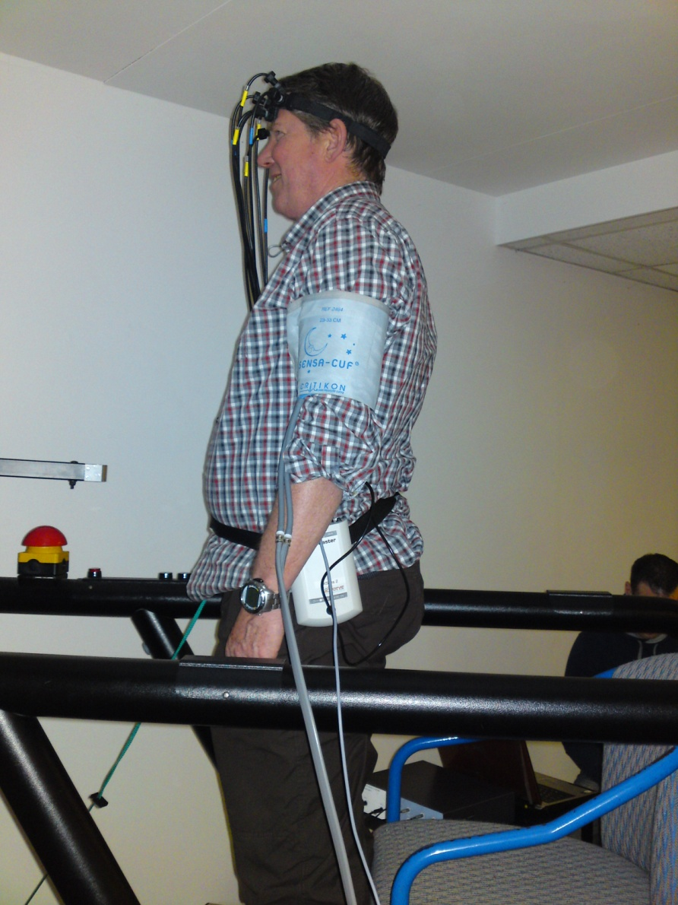 NIRS during standing and walking

and during b) for participants who are willing and able to participate in MRI scanning we will examine brain functioning during foot tapping in an MRI scanner. Brain activation will be measured during functional magnetic resonance imaging at the Radcliffe Hospital (fMRIB). Not everyone will be suitable for Magnetic Resonance Imaging (MRI) scanning and only a subset of 26 people will have their brain functioning measured in this way. During both walking and simulated walking we will ask you to walk and then perform a thinking task and then to perform both tasks at the same time.

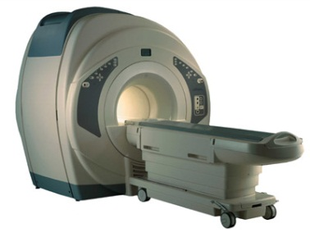 MRI Scanner

3) Explore how well you and your carer cope with the training programmes.

We will determine the effect of walking whilst performing distracting tasks training on your walking. We will explore the underlying brain functioning changes that are related to walking changes in order to better understand and thus inform how to best rehabilitate people after a stroke. We will do this through a telephone interview.

**What are the possible disadvantages and risks of taking part?**

* **MRI**: There are minimal risks to people undergoing a MRI scan; there is no x-ray or any radiation involved. The MRI scan is a safe, common hospital procedure and involves the patient being placed in a magnetic field which can then show us body structures and how they are functioning. Any patient with certain metal objects within their head or trunk, those who are claustrophobic or pregnant cannot take part in this study.
* **NIRS**: NIRS has been noninvasively and extensively utilisied in human research for brain imaging muscle. It is basically shining an infrared light onto the scalp, and detecting it as it exits the head. It has been used in clinical practice in hospitals (special care baby units) over many years.
* **Walking exercise:** Exercise training will be carried out in the Clinical Exercise Testing and Rehabilitation Unit, Oxford Brookes University. The unit is staffed by MSc level trained exercise professionals (Register of Exercise Professionals level 4) experienced in prescribing and monitoring exercise in clinical populations and by physiotherapists. Staff are first aid trained and the Unit has standard health and safety procedures. Exercise training will be individually prescribed from exercise testing data. All exercise sessions will be monitored with recording of blood pressure prior to training and heart rate, performance and perceived exertion during training

**What are the possible benefits of taking part?**

Treadmill walking exercise has been shown to be an effective intervention for improving mobility, health, wellbeing and fitness in people following stroke. Participants in both groups will benefit from participation in treadmill walking.

**What happens when the research study stops?**

After you have attended all sessions, your participation in the study would end. Once a sufficient amount of data is collected, we will analyse the data and report the results in scientific journals without mentioning any names. You will still be free to contact us and if you wish we would be happy to send a copy of the published report to you.

**What if there is a problem?**

Any complaint about the way you have been dealt with during the study or any possible issues will be addressed. The detailed information on this is given in Part 2.

**Will my taking part in the study be kept confidential?**

Yes. We will follow standard ethical and legal practice and all information about you will be handled in confidence. The details are included in Part 2.

If the information in Part 1 has interested you and you are considering participation, please read the additional information in Part 2 before making any decision.

**Information about the research; Part 2**

**What if relevant new information becomes available?**

Sometimes we get new information that informs better rehabilitation. If this is pertinent to your involvement in this study, your doctor` will tell you and discuss whether you should continue in study.

**What will happen if I don’t want to carry on with the study?**

Your participation is entirely voluntary. You are free to decline to enter or withdraw at any time, without having to give a reason. If you choose to withdraw once entered, this will not affect your future medical care. You can withdraw from any part of the study but keep in contact with us to let us know your progress. Information collected may still be used.

**What if there is a problem?**

If you have a concern about any aspect of this study, you should ask to speak to the researchers who will do their best to answer your questions (01865 483272). If you remain unhappy and wish to complain formally, you can do this through the NHS Complaints Procedure (or Private Institution). Details can be obtained from the hospital.

**What if something goes wrong?**

If you are harmed by taking part in this research project, there are no special compensation arrangements. If you are harmed due to someone’s negligence, then you may have grounds for a legal action but you may have to pay for it. Regardless of this, if you wish to complain, or have any concerns about any aspect of the way you have been approached or treated during the course of this study, the normal National Health Service and University complaints mechanisms should be available to you.

**Will my taking part in this study be kept confidential?**

We would like to reassure you that your personal and medical details would be kept strictly confidential. No one except the named researchers would have access to these details or your medical notes, and no identifying details would appear in our published results. Any information about you, which leaves the hospital, will have your name and address removed so that you cannot be recognised from it. If you wish we would provide you with a summary of the final results. Any information about you would have your name and address removed so you cannot be recognised.

**What will happen to the results of the research study?**

The results of the study may be presented at conferences and published in medical or scientific journals and used as part of a PhD thesis. If you would like we can inform you of where you can obtain a copy of the published results. You would not be identified in any of the reports. Measures we use for this study and that are also used in routine care will be added to your medical records after data collection is complete. This is done to avoid unnecessary extra testing.

**Will my GP be informed?**

We don’t think it is necessary to notify your GP about your participation in this research project. However, if you wish we can do so for you. We will ask your permission to do this.

**Who is organising and funding the research?**

The research is funded by the Stroke Association UK, and is led by Prof. Helen Dawes, Movement Science Group, Oxford Brookes University.

**Who has reviewed the study?**

The study has been reviewed and ethical permission approved by the South Central- Oxford C Oxfordshire Research Ethics Committee (REC) and the Oxford Brookes University Faculty of Life and Health Sciences ethical officer.

**Contact for Further Information**

The study is being carried out by: Prof Helen Dawes (research physiotherapist), Emad Al-Yahya (research physiotherapist), Prof. Heidi Johansen-Berg (scientist), Prof Derick Wade (consultant in neurological rehabilitation), Prof Udo Kishna), Daan Meester and Bryony Sheriden. If you have any questions or queries please don’t hesitate to contact:

## Helen Dawes

## Phone: 01865 483293

## Email: nhdawes@brookes.ac.uk

Or

Daan Meester

Phone: 01865 483272

Email: dmeester@brookes.ac.uk

**You will be given a copy of the information sheet and a signed consent form to keep.**