THE ARNI INSTITUTE FUNCTIONAL REHABILITATION & EXERCISE TRAINING AFTER STROKE QUALIFICATION
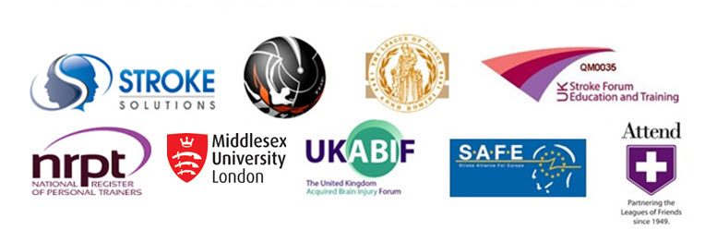

Please complete in full and send back to the Programme Co-ordinator at the ARNI Institute.
The form will be held in complete confidentiality at ARNI Institute Central.

COURSE: The ARNI Institute Functional Rehabilitation & Exercise Training After Stroke Qualification
YEAR OF ENTRY: 2017
SPONSORING CLINIC, NETWORK, COUNCIL, ORGANISATION OR CHARITY:
(If none, please state ‘independent’)

SURNAME:

FIRST NAME(S):

DATE OF BIRTH:

NATIONAL INSURANCE NUMBER:

PRESENT ADDRESS:

TELEPHONE: HOME: MOBILE:

EMAIL ADDRESS:

OTHER EMAIL ADDRESS (if necessary):
CURRENT OCCUPATION:

NAME OF ORGANISATION (if applicable):

ROLE:

START DATE:
ORGANISATION ADDRESS:

BRIEF EDUCATION HISTORY (Eg. state your education history to date)

BRIEF EMPLOYMENT HISTORY (Eg. state your employment history to date)

RELEVANT QUALIFICATIONS:
(list other qualifications, membership of professional bodies, national registers, medical forums etc)

IS YOUR CRB CHECK CURRENT? YES NO

YOUR INSURANCE DETAILS Please provide all necessary current details:

PRIOR EXPERIENCE WITH STROKE POPULATION
(Eg. any relevant experience with stroke survivor(s) or therapy given)

Please read carefully and sign. You can use a jpg scan of your own signature or print out and sign.

1. I understand that the ARNI Institute Functional Rehabilitation & Exercise Training After Stroke Qualification enables me to:
1. consider the latest therapy evidence base, from initial trauma to rehabilitation at home and understand the latest neurological developments in stroke rehabilitation research.
2. learn the latest reality-based strategies developed for treating and training stroke survivors in the clinic and community.
3. Apply to become an ARNI Associate Instructor and start to receive direct referrals in my area.

2. I understand that the ARNI Functional Rehabilitation & Exercise Training After Stroke Qualification is designed to enhance knowledge and skills in the area of stroke rehabilitation and grants the successful completer the ARNI FRETS Qualification Certificate.

2. I understand that the ARNI Institute Functional Rehabilitation & Exercise Training After Stroke Qualification is Accredited by Middlesex University at FHEQ Level 4 (HE Level 1) granting 30 credits with separate Certificate granted for the successful completer.

PLEASE SIGN HERE: DATE:

Please send to:
Mrs. Dee Balchin, Programme Co-ordinator,
The ARNI Institute, PO Box 68, Lingfield, Surrey, RH7 6QQ, UK.

The ARNI Institute – A UK Registered Charity (No. 1116130)
….working for stroke survivors

