

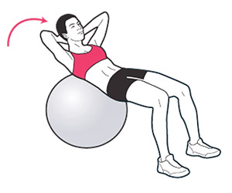

We are investigating the effect of exercise balls on balance strategies used by people with stroke.

**We would like to recruit people with stroke, able to walk independently**

We will ask you to sit on a chair and a ball. While you are seated, we ask you to lift one arm or leg as quickly as possible and record the electrical activities in the muscles you normally use to maintain balance. We will ask you to do this, under different conditions, such as a mental task that requires you to identify whether names announced to you is male or female or the ear in which the sound was heard.

You will only need to attend the laboratory once, for 2 hours. The study will take place at Charing Cross Hospital.

If you would be interested in taking part, please contact:

**Dr Paul Strutton 020 331 38837 (internal ext 38837) or email** [**p.strutton@imperial.ac.uk**](mailto:p.strutton@imperial.ac.uk)